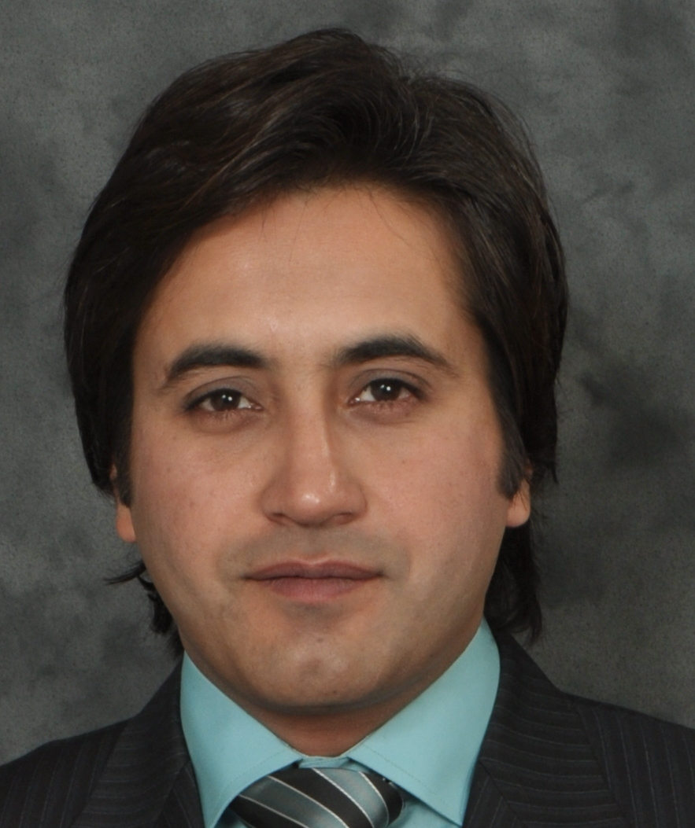

Curriculum Vitae

PERSONAL INFORMATION

Surname |  | Jahan
Name |  | Jahanzeb
Postal address |  | House No.65, Block 1, Sector C1 Township, Lahore – 54900
Telephone |  | +92-300-4152010
E-mail |  | jahanzeb@ue.edu.pk
Nationality |  | Pakistani
Date of birth |  | 12.04.1984

Education and training

• Date (from – to) |  | 2010-2013
• Name and type of organisation providing education and training |  | University of Management and Technology
Duration of the program of study |  | 3 Years
• Principal subject |  | Applied Linguistics
• Title of qualification awarded |  | M.Phil Applied Linguistics
• Research focus or interest |  | Computer Mediated Communication
• Title of the Thesis |  | Diachronic Analysis of Orthographic Patterns of Computer Mediated Communication
CGPA |  | 3.17
Distinction |  | I topped my session among boys.
• Date (from – to) |  | 2003-05
• Name and type of organisation providing education and training |  | University of the Punjab, Lahore
Duration of the Program of Study |  | 2 Years
• Principal subject |  | English Literature
• Title of qualification awarded |  | Master of Arts English (Topper of my session)
Final mark obtained |  | 2nd Division
• Date (from – to) |  | 2001-03
• Name and type of organisation providing education and training |  | Forman Christian College Lahore
Duration of the program of study |  | 2 Year
• Principal subject |  | English Literature, Political Science
• Title of qualification awarded |  | Bachelors of Arts
Final mark obtained |  | 2nd Division
• Date (from – to) |  | 1999-2001
• Name and type of organisation providing education and training |  | Board of Intermediate and Secondary Education, Rawalpindi
Duration of the program of study |  | 2 Years
• Principal subject |  | Political Science
• Title of qualification awarded |  | Faculty of Arts (HSSC)
Final mark obtained |  | 743/1100 with distinction of first position in the whole Rawalpindi Board
• Date (from – to) |  | 1997-2001
• Name and type of organisation providing education and training |  | Board of Intermediate and Secondary Education, Sargodha
Duration of the program of study |  | 2 Years
• Principal subject |  | Arts
• Title of qualification awarded |  | Faculty of Arts (SSC)
Final mark obtained |  | 569/800 with distinction of second position in Sargodha Board acquiring a Silver Medal
Year |  | 2003
• Name and type of organisation providing education and training |  | University of the Punjab, Lahore
• Title of qualification awarded |  | Diploma English Spoken Skills
Final mark obtained |  | A

Publications and conference papers

Author(s) and title |  | Jahanzeb Jahan, Kiran Jahanzeb  Diachronic Change in English Orthography with Proliferation of CMC
Language |  | English
Conference |  | First National Conference on English Language and Literature
Place |  | University of Education, Lahore, Pakistan
Published Book |  | Understanding English Language and Communication Skills
Language |  | English
Year |  | 2016
Place |  | Lahore, Pakistan
Published Book |  | Prologue to the Canterbury Tales (A Critical Book on the 14th Century Poem of Chaucer)
Language |  | English
Year |  | 2009
Place |  | Lahore, Pakistan
Published Book |  | Rape of the Lock (A Critical Book on the 18th Century Poem of Alexander Pope)
Language |  | English
Year |  | 2008
Place |  | Lahore, Pakistan
Published Book |  | Muhammad ﷺ the Messenger; The Crown of Creation
Language |  | English. First Ever Poem on the life of Holy Prophet ﷺ Using Alliteration in All the Lines.
Year |  | 2008
Place |  | Lahore, Pakistan (Under Publishing Process)
Author(s) and title |  | Jahanzeb Jahan, Kiran Jahanzeb  Semantic Change in English Language: Social Media Neologisms
Language |  | English
Conference |  | First Interational Conference on English Language and Literature
Place |  | University of Education, Lahore, Pakistan, December 2018
Author(s) and title |  | Jahanzeb Jahan, Ghumama Amjad  Effect of Political Rhetoric in Developing Aggression and Political Violence among People
Language |  | English
Conference |  | Interational Conference on English Language and Literature
Place |  | University of Management & Technology, Lahore, Pakistan, March 2019
Author(s) and title |  | Jahanzeb Jahan, Hafiz Syed Yasir Mehmood  Inferiority Complex Syndicated with the Language: A Psychological Facet
Language |  | English
Conference |  | Interational Conference on English Language and Literature
Place |  | University of Education, Lahore, Pakistan, December, 2018.
Author(s) and title |  | Jahanzeb Jahan, Hafiz Syed Yasir Mehmood  E-Learning Stratagem in Escalation of Learning Termination: An Orthodox Comparison
Language |  | English
Conference |  | Interational Conference on English Language and Literature
Place |  | University of Education, Lahore, Pakistan, 2019.
Author(s) and title |  | Jahanzeb Jahan, Kanwal Shehzadi  Parveen Shakir’s Poetry and Foregrounded Irregularities in Her Poetry
Language |  | English
Conference |  | International Conference on English Language and Literature
Place |  | University of Education, Lahore, Pakistan, 2019.
Author(s) and title |  | Jahanzeb Jahan, Zuha Warsi  The Effect of Illustration on the Comprehension of Comic Book Readers
Language |  | English
Conference |  | Interational Conference on English Language and Literature
Place |  | University of Education, Lahore, Pakistan, 2019.
Author(s) and title |  | Jahanzeb Jahan, Ushna Hafeez, Kainat Imdad  Linguistic Colonization of Decolonized Nation: An Interrogation of Institutes Offering Spoken English Courses
Language |  | English
Conference |  | Interational Conference on English Language and Literature
Place |  | UMT, Lahore, Pakistan, March 2019.

Conferences Attended and Managed

5th Nov 2007 to 7th Nov 2007 |  | First International Conference on Quality Teacher Education, Promises and Practices.
26th March 2008 to 28th March 2008 |  | International Conference on Transforming Teacher Education, Improving Practicum and Internship.
24-26th March, 2017 |  | 5th International Conference on Education in Pakistan: Building Bridge between Mathematics, Science & Technology and Teacher Education
December 2017 |  | National Conference on English Language and Literature (NCELL)
2018 |  | 1st National Conference on Counter Balancing Politics and Aesthetics in Pakistani Literature by University of Punjab and Higher Education Commission.
2018 |  | International Conference on English Language, Literature and teaching (ICELLT)
2018 |  | Participated and Contributed in 2nd Annual English Poetry Recitation in University of Education.

Workshops, Seminars and Courses Attended

August to November 2008 |  | CAL Course (Computer Assisted Learning) from Agha Khan University, Karachi (August to November 2008)
12th Nov to 14th Nov 2008 |  | 7 Habits of Highly Effective People, A Signature Programme. (12th Nov to 14th Nov 2008)
8th-9th May, 2015 |  | 02 Day Orientation Workshop on Policy Guidelines for Semester Examination System, by Higher Education Commission, Pakistan
9th June, 2015 |  | Seminar on Latest Trends in ELT & Status of Language Teaching at UE
3rd-6th August, 2015 |  | Assessing Research Proposal in IBA Karachi by Higher Education Commission
28th December, 2016 |  | Seminar on “Producing Effective Graduates: A Challenge for Quality Assurance in Higher Education” by Virtual University and University of Education, Lahore.
20th-22nd September, 2017 |  | Training on Testing and Evaluation by Higher Education Commission, Pakistan

Test / Certifications

IELTS |  | Over all 7 Bands (Speaking 7.5, Listening 7.5, Reading 6.5, Writing 6.5)
Diploma |  | English Spoken Skills, Passed with A Grade

Professional work Experience

• Date (from – to) |  | October 2007 to date
• Name and address of university |  | University of Education, Lahore-Pakistan.
• Position |  | Lecturer Officer (BS 87)
• Type of employment |  | Permanent

Major Duties and Tasks Performed |  | - Taught English language and literature courses at masters level  - Member of Toastmasters International  - Supervised a number of Thesis  - Revised, Proof read and Edited BS English and MA English Scheme of Studies  - Working as internal incharge Examinations since 2014  - Worked as Focal Person Prime Minister’s National Laptop Scheme since 2014  - Managing UMS (University Management System) at Campus Level  - Worked as Convener Registration Committee in National conference of English language and literature (NCELL).  -Worked as Convener Registration Committee in International Conference on English Language, Literature and Teaching (ICELLT)  - Organised many seminars and trained the teachers in few training programs.  - Working as Incharge Sports Committee of my Campus since 2016  -Workied as Convener Registration Committee in International Conference of QEC in 2019

Personal skills and competences

Mother tongue |  | Urdu

Other language(s)
 |  | English
• reading |  | Proficient
• writing |  | Proficient
• speaking |  | Proficient

Outstanding Personal Achievements |  | - I won the story writing competition in Sub-region.  - I stood 1st in class in my entire academic career.  - I topped Sargodha Board in Matriculation (Arts)  - I topped Rawalpindi Board in Inter (Part-I).  - I topped my class in M.A English. (F.C College Lahore)

Technical skills and competences |  | Microsoft Office (Word, Excel, PowerPoint, Publisher)  SPSS

Co-curricular Activities |  | - I have served as the President of Musical Society of F.C College Lahore.  - I have been the Class Representative in my M.A Session.  - I also worked as the Vice-President of English Literary Circle.  - I have been the General Secretary of Forman Christian Environmental Club.

Major Subjects Taught |  | Out of many, I have taught and enjoyed the following courses to the best of students’ satisfaction:  i). Classical Poetry:  ii). Romantic and Modern Poetry  iii). Prose  iv) American Literature  v) English Language Communication Skills  vi) 18th Century Novel  vii) Methods of Teaching English at Secondary Level  viii) Functional English  ix) Business Communication  x) Greek and Roman Drama  xi) Modern Novel  xii) Introduction to Linguistics  xiii) Psycholinguistics  xiv) Sociolinguistics  xv) Research Methodology  xvi) Semantics & Pragmatics  xvii) Language, Culture and Identity  xviii) Lexical Studies  xix) Creative Writing  xx) Academic Reading and Writing

